**Project Report**

ON

SUPPLY CHAIN MANAGEMENT

Created By

**BHUMI SOLANKI**

**PGDCA SEM-2**

under the guidance of

**PROF. HARSH JOSHI**

Submitted To

**GEETANAJALI COLLEGE OF COMPUTER SCIENCE &amp; COMMERCE**



Affiliated To

**SAURASTRA UNIVERSITY**

For Academic Year

**2022-23**

**Acknowledgement:**

The project on **SUPPLY CHAIN MANAGEMENT SYSTEM** is developed in **PHP** Language at **GEETANJALI COLLEGE OF COMPUTER SCIENCE & COMMERCE.**

I would like to acknowledge that my project has been completed and I am ensuring that, in this accomplishment, I would like to express my special gratitude to all my teachers and specially to **PROF. HARSH JOSHI** without their guidance and feedback it is not possible to complete this assignment.

**Index**

**PERTICULARS**

* **Introduction**

**• Abstract**

* **Project Profile**
* **SDLC process model**
* **Software Resources**
* **List of Modules**
* **Use Case Diagram**
* **Snapshots**
* **Conclusion**
* **Webliography**

**INTRODUCTION**

**Abstract**

**The main objectives of this project are to maintain information about product and other information like manfucturer, distributor and retailer as well as manufacture,distributor and retailer can change their security password.**

**Admin can add new manufacturer.**

**Manufacturer can add new distriutor.**

**Distributor can add new retailer.**

**Project Profile**

|  |  |
| --- | --- |
| **Project Name** | Supply Chain Managment System |
| **Development software** | Notepad++ |
| **Back End Tool** | SQL Server |
| **Academic Year** | 2022-23 |
| **Project Platform** | PHP |
| **Programming Language** | Html, CSS, PHP ,JavaScript ,Boostrap |
| **Project Type** | Web Application |
| **Developed By** | BHUMI G. SOLANKI |
| **Submitted To** | GEETANJALI COLLEGE |

Process Model

The Process Model used in our projects "Supply Chain Management System" is waterfall model.

**The Waterfall Model:**

The waterfall model is a sequential design process, used in software development processes, in which progress is seen as flowing steadily downwards (like a waterfall) through the phases of Conception, Initiation, Analysis, Design, Construction, Testing, Production/Implementation and Maintenance. The waterfall development model originates in the manufacturing and construction industries: highly structured physical environments in which after-the-fact changes are prohibitively costly, if not impossible. Since no formal software development methodologies existed at the time, this hardware-oriented model was simply adapted for software development.

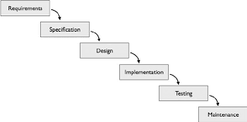

* **Reason the waterfall model in the software development cycle:**
* Since we have well known, clean and fixed requirements therefore it best suits for our software development.
* Our product definitions are stable.
* Technology is clearly understood.
* The project is short.
* **Advantages of the waterfall model:**
* This model is simple and easy to understand and use. In, this model phases are processed and completed one at a time and phases do not overlap.
* Waterfall model works well for smaller projects where sequence is very well understood.

**Software Resources**

**Backend Design Tool:** Microsoft SQL server

**Code-Behind Language:** PHP

* Functionality:
* Login/Logout
* Add Category
* Add unit
* Add Product
* Update,delete product
* Add Manufacture
* Update Delete Manufactur
* **Login Of Modules**
  + - * Admin Login
      * Manufacturer Login
      * Distributor Login
      * Retailer Login

Data Dictionary

**Admin Login Table**

|  |  |  |
| --- | --- | --- |
| Columns | Datatype | Constrainst |
| id | **int** | **PK** |
| username | **varchar(100)** | **Not Null** |
| password | **varchar(100)** | **Not Null** |

**Categories Table**

|  |  |  |
| --- | --- | --- |
| Columns | Datatype | Constrainst |
| cat_id | **int** | **PK** |
| cat_name | **varchar(30)** | **Not Null** |
| cat_details | **text** | **Null** |

**Unit Table**

|  |  |  |
| --- | --- | --- |
| Columns | Datatype | Constrainst |
| id | **int** | **PK** |
| unit_name | **varchar(30)** | **Not Null** |
| Unit_description | **varchar(30)** | **Null** |

**Product Table**

|  |  |  |
| --- | --- | --- |
| Columns | Datatype | Constrainst |
| id | **int** | **PK** |
| pro_name | **varchar(30)** | **Not Null** |
| pro_cat | **Int** | **PK** |
| pro_unit | **int** | **PK** |
| Pro_desc | **text** | **Null** |
| pro_price | **varchar(10)** | **Not Null** |
| pro_image | **varchar(30)** | **Not Null** |

**Area Table**

|  |  |  |
| --- | --- | --- |
| Columns | Datatype | Constrainst |
| area_id | **int** | **PK** |
| area_name | **varchar(50)** | **Not Null** |
| Area_code | **varchar(30)** | **Not Null** |

**Manufacturer Table**

|  |  |  |
| --- | --- | --- |
| Columns | Datatype | Constrainst |
| man_id | **int** | **PK** |
| man_name | **varchar(50)** | **Not Null** |
| man_email | **varchar(30)** | **Not Null** |
| man_phone | **varchar(20)** | **Not Null** |
| username | **Varchar(30)** | **NOt Null** |
| password | **Varchar(10)** | **Not Null** |

**Distributor Table**

|  |  |  |
| --- | --- | --- |
| Columns | Datatype | Constrainst |
| id | **int** | **PK** |
| dist_name | **varchar(30)** | **Not Null** |
| dist_email | **varchar(30)** | **Not Null** |
| dist_phone | **varchar(10)** | **Not Null** |
| dist_address | **text** | **Not Null** |
| username | **Varchar(30)** | **Not Null** |
| password | **Varchar(10)** | **Not Null** |

**Retailer Table**

|  |  |  |
| --- | --- | --- |
| Columns | Datatype | Constrainst |
| retailer_id | **int** | **PK** |
| retailer_name | **varchar(30)** | **Not Null** |
| phone | **varchar(10)** | **Not Null** |
| email | **Varchar(10)** | **Not Null** |
| area_code | **Varchar(10)** | **Not Null** |
| address | **text** | **Not Null** |
| username | **Varchar(30)** | **Not Null** |
| password | **Varchar(30)** | **Not Null** |

**Order**

**Area Table**

|  |  |  |
| --- | --- | --- |
| Columns | Datatype | Constrainst |
| order_id | **int** | **PK** |
| Pro_name | **varchar(50)** | **Not Null** |
| Pro_price | **varchar(30)** | **Not Null** |
| Pro_qnt | **varchar(30)** | **Not Null** |

DFD [Data Flow Diagram]

Data flow diagram symbol

|  |  |
| --- | --- |
| sSymbol | Description |
|  | **Data Flow** – Data flow are pipelines through the packets of information flow. |
|  | **Process** : A Process or task performed by the system. |
|  | **Entity** : Entity are object of the system. A source or destination data of a  system. |
|  | **Data Store** : A place where data to be stored. |

* **DFD (Context Diagram):**

Database

Admin

**Use Case Diagram**

**admin**

Change Password

Add Manufucturer

Manage-Categories

Manage Area

Manage Unit

Add Product

**Use Case Diagram**

Profile

**Manufacturer**ere

Manage Category

Manage Unit

Add Product

Add Distributor

**Use Case Diagram**

**Use Case Diagram**

**Distributorr**

Manage Category

Manage Unit

Manage Stock

Add Product

Add Retailer

Profile

**retailer**

Profile

Product Oreder

**snap shots**

**login page**

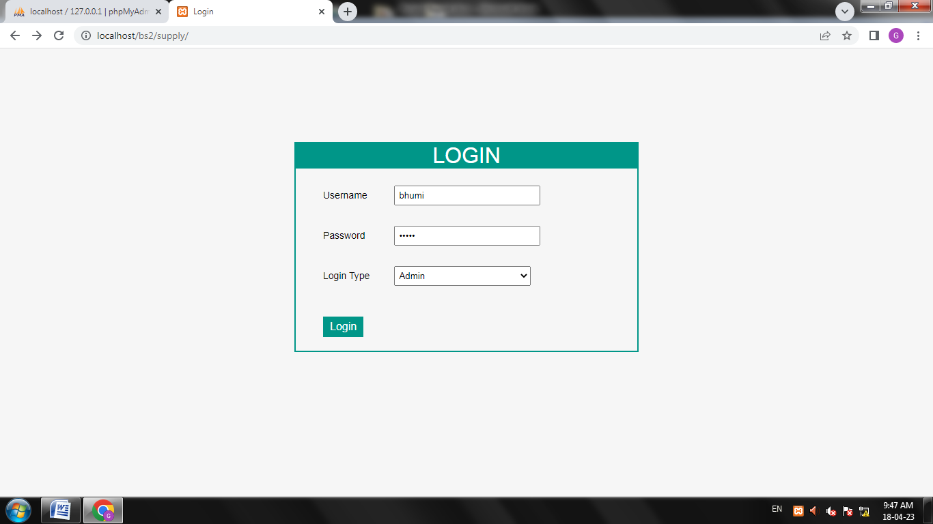

**home**

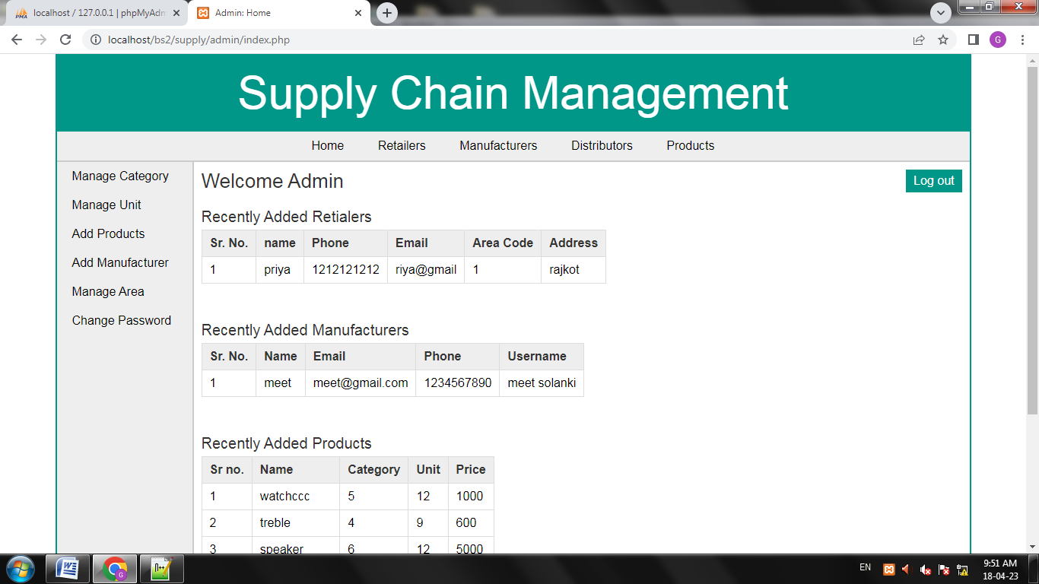**add category**

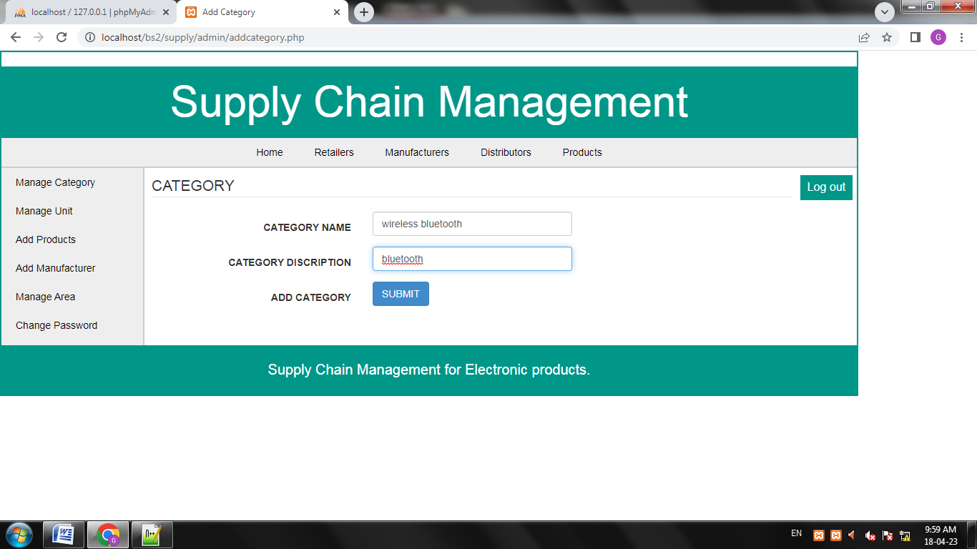

**manage category**

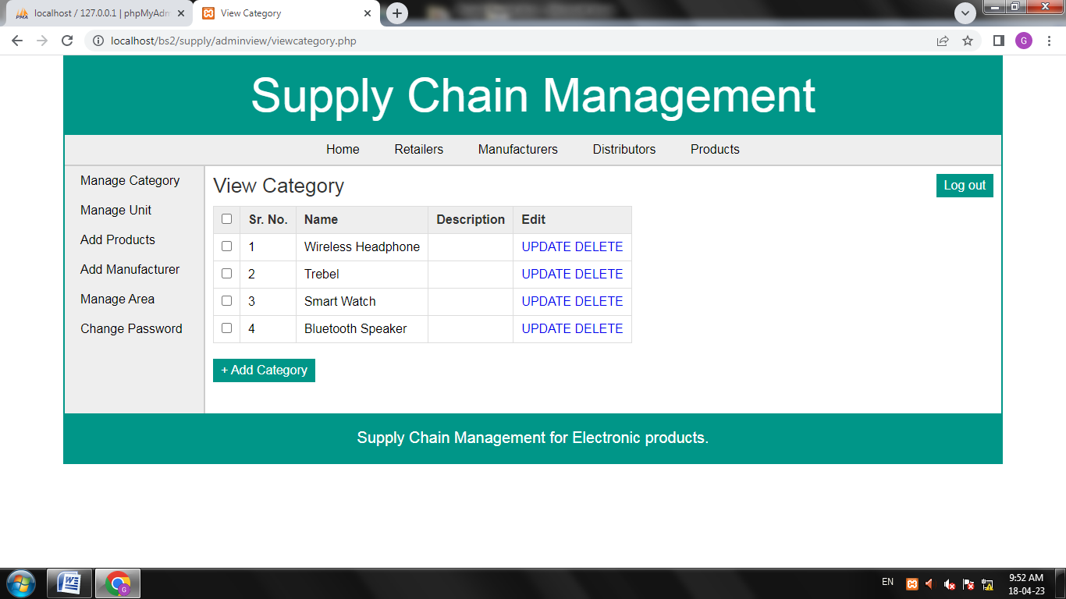

**add unit**

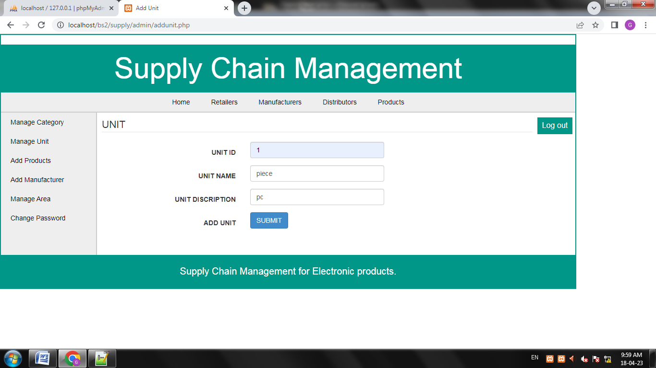

**manage unit**

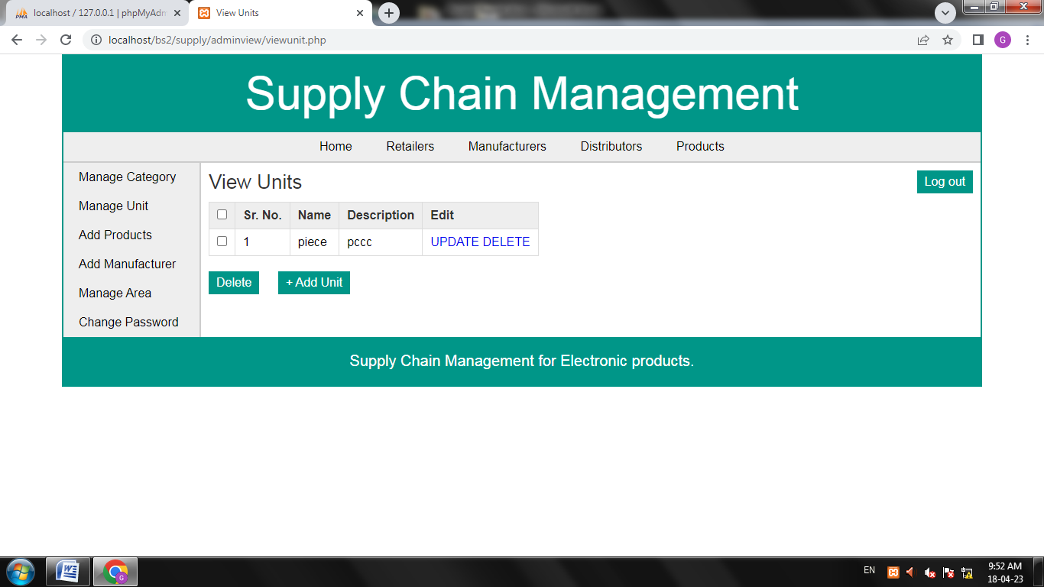

**Add product**

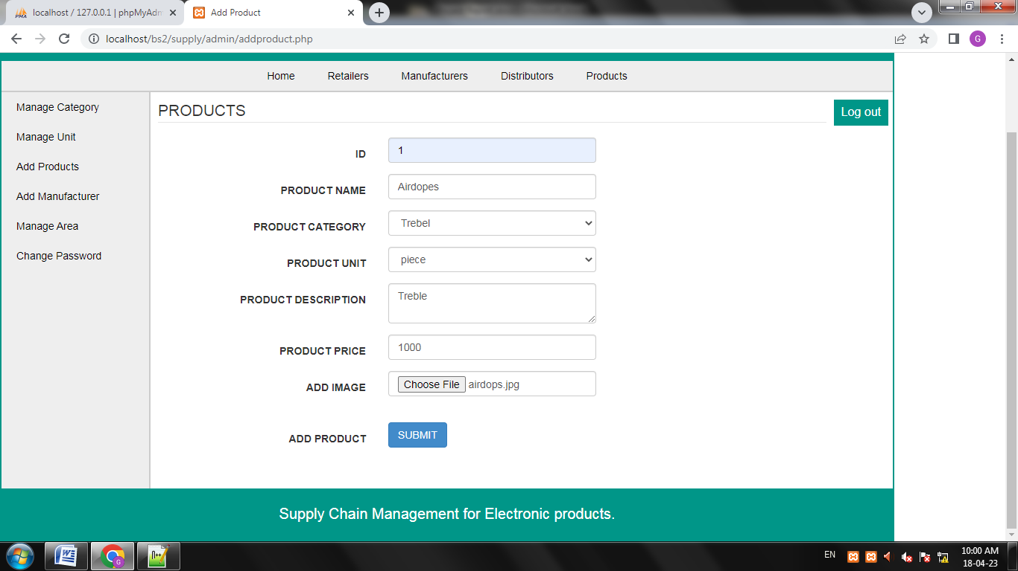

**add manufacturer**

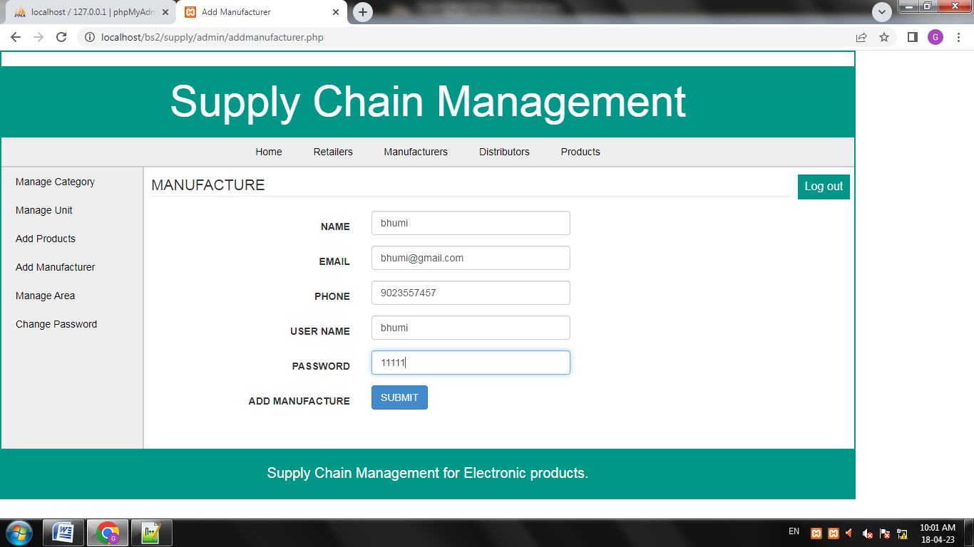

**Add Area**

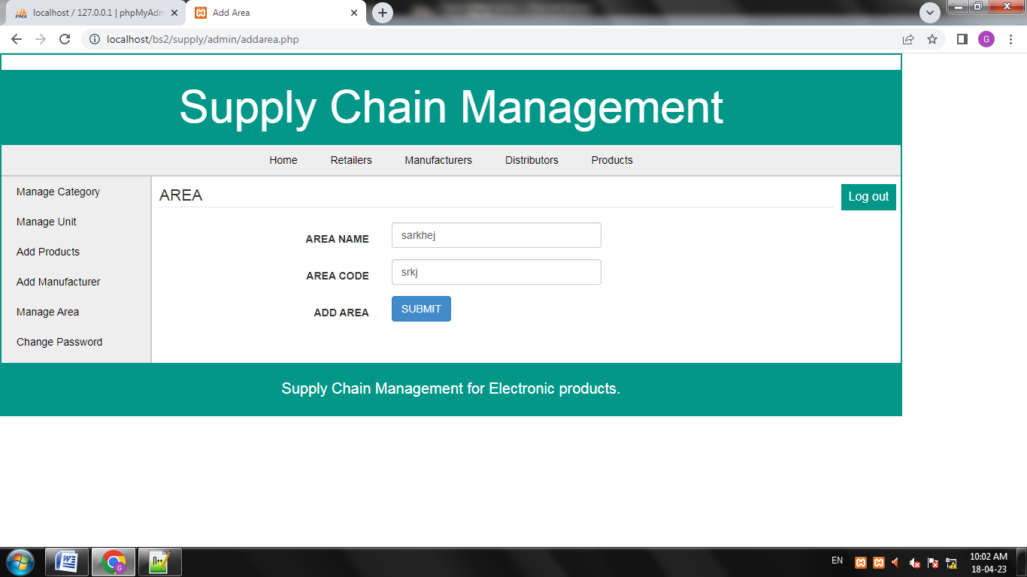

**Manage Area**

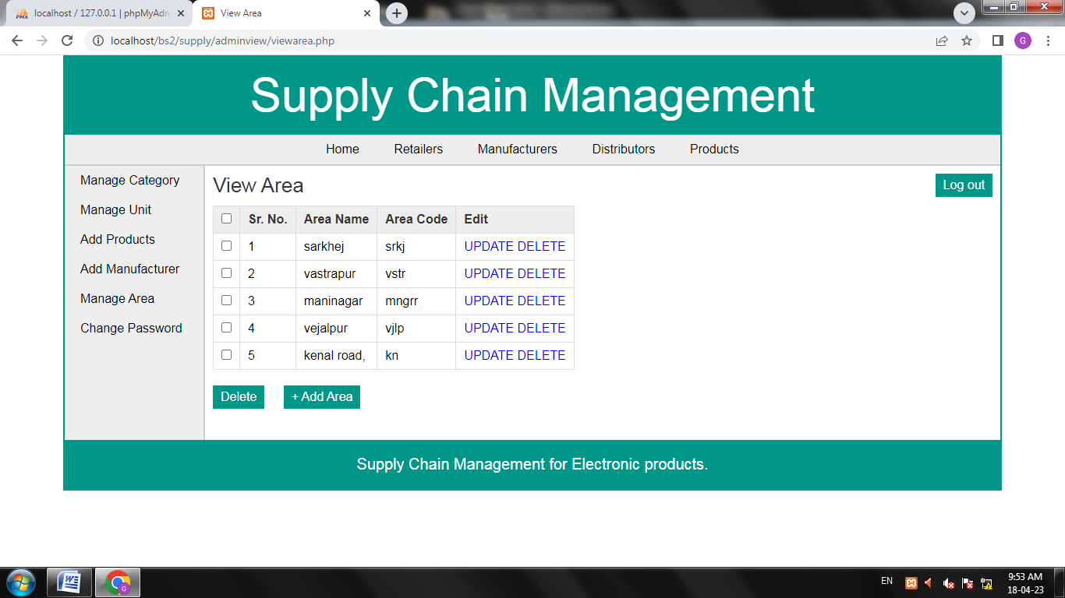

**Change password**

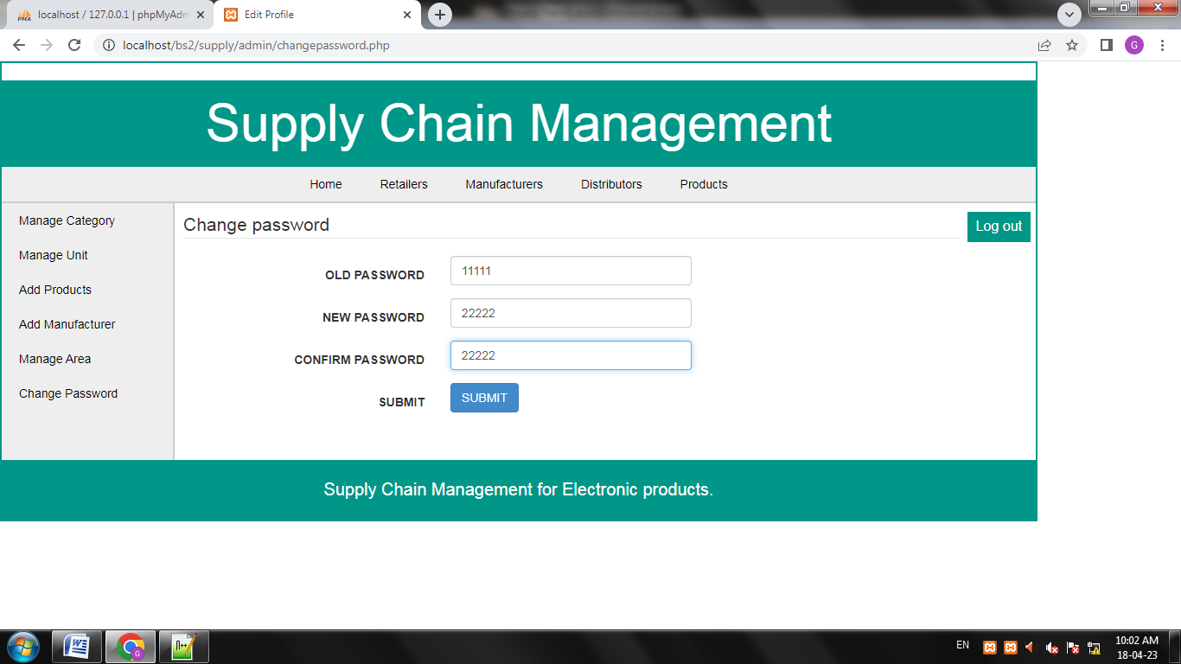

**Retailer**

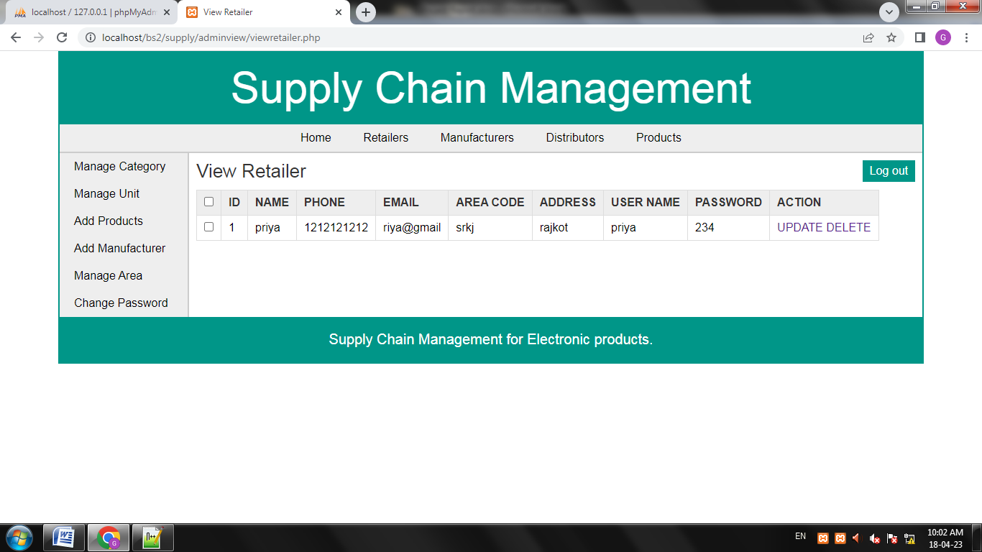

**Manufacture**

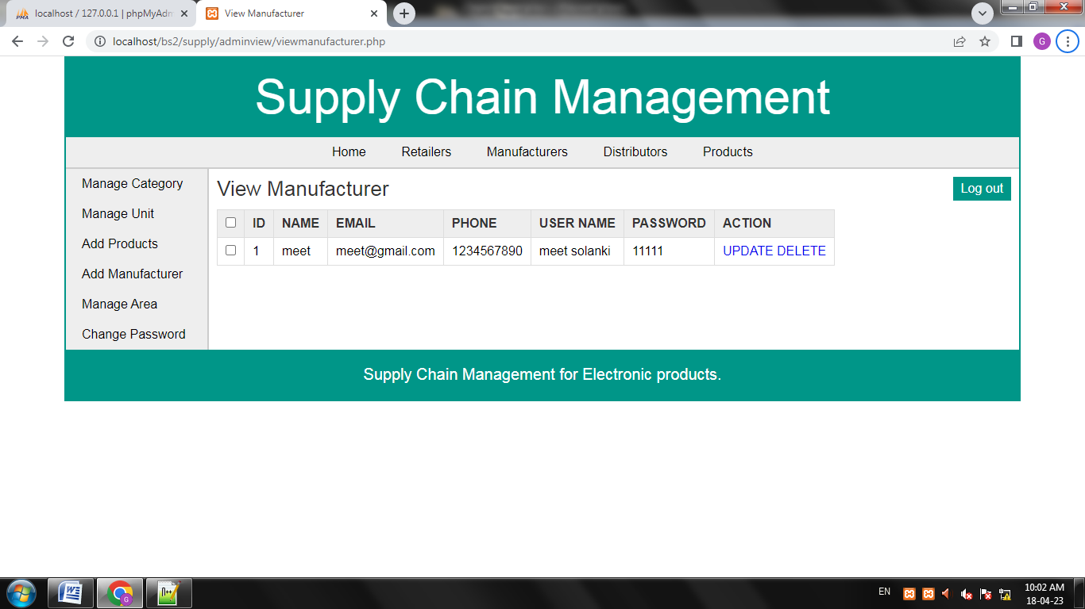

**Distributor**

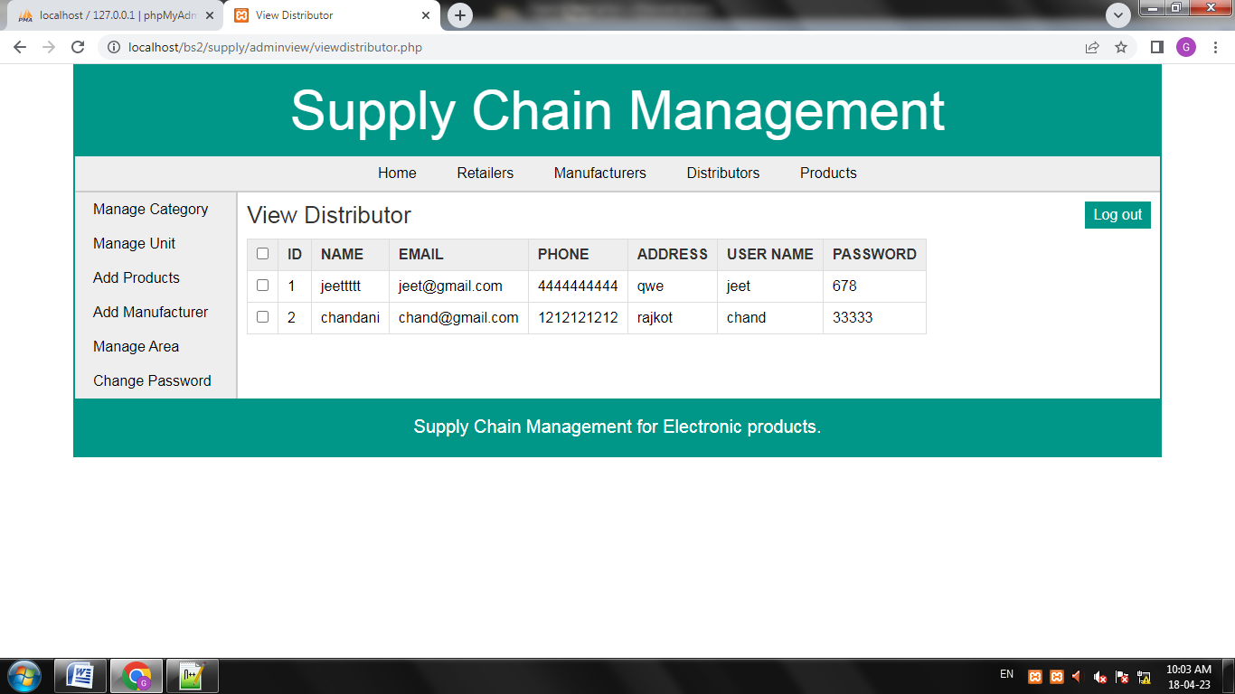

**Product**

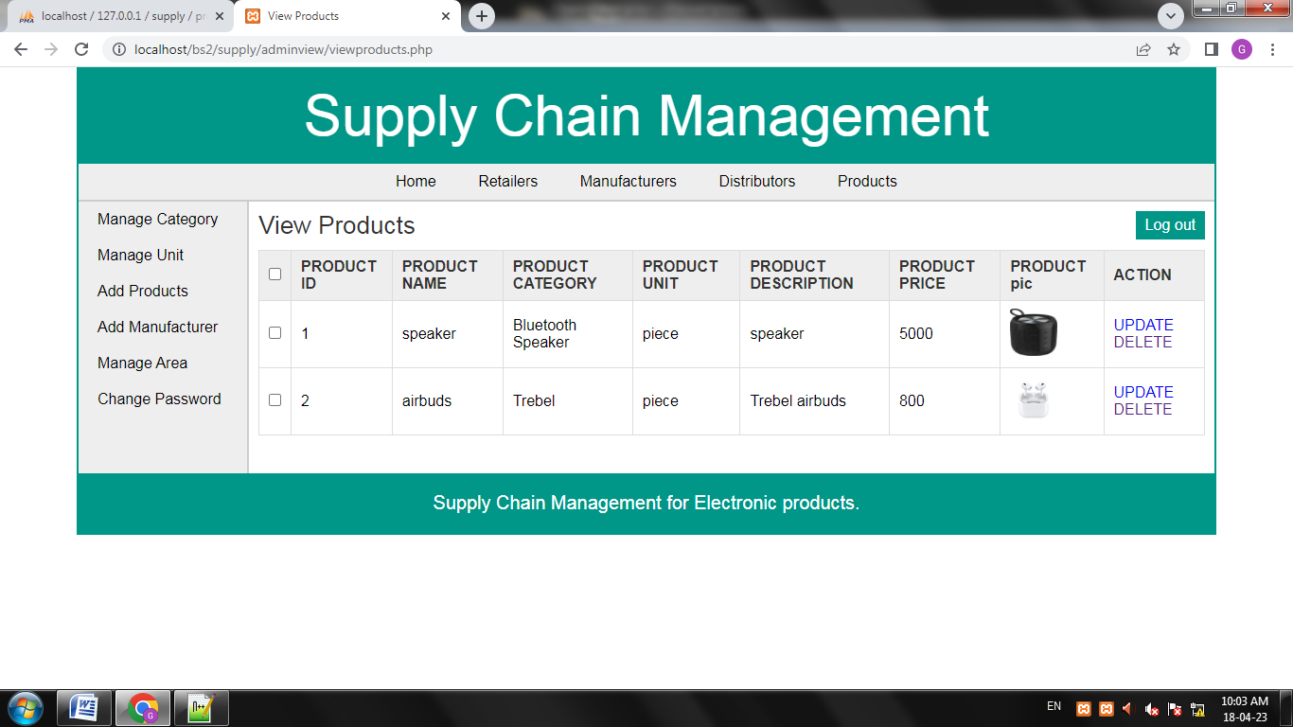

**Manufacturer Login**

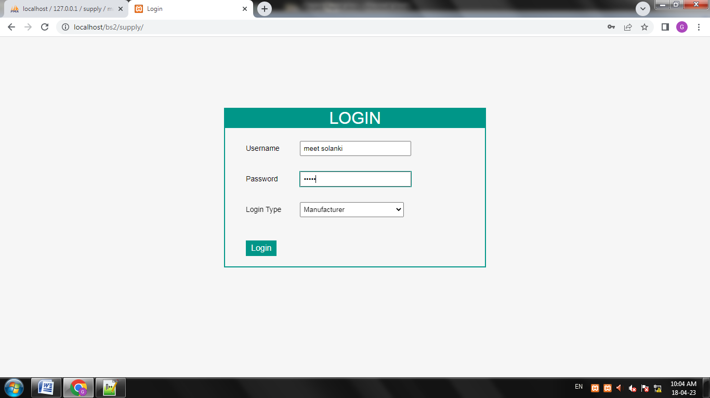

**Home**

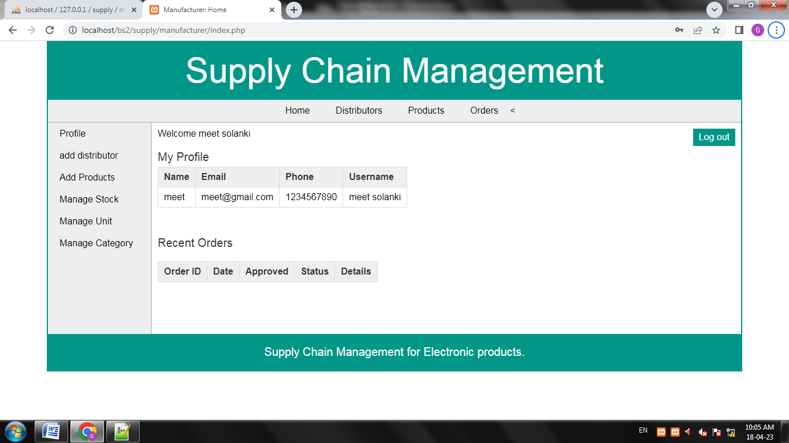

**Logout**

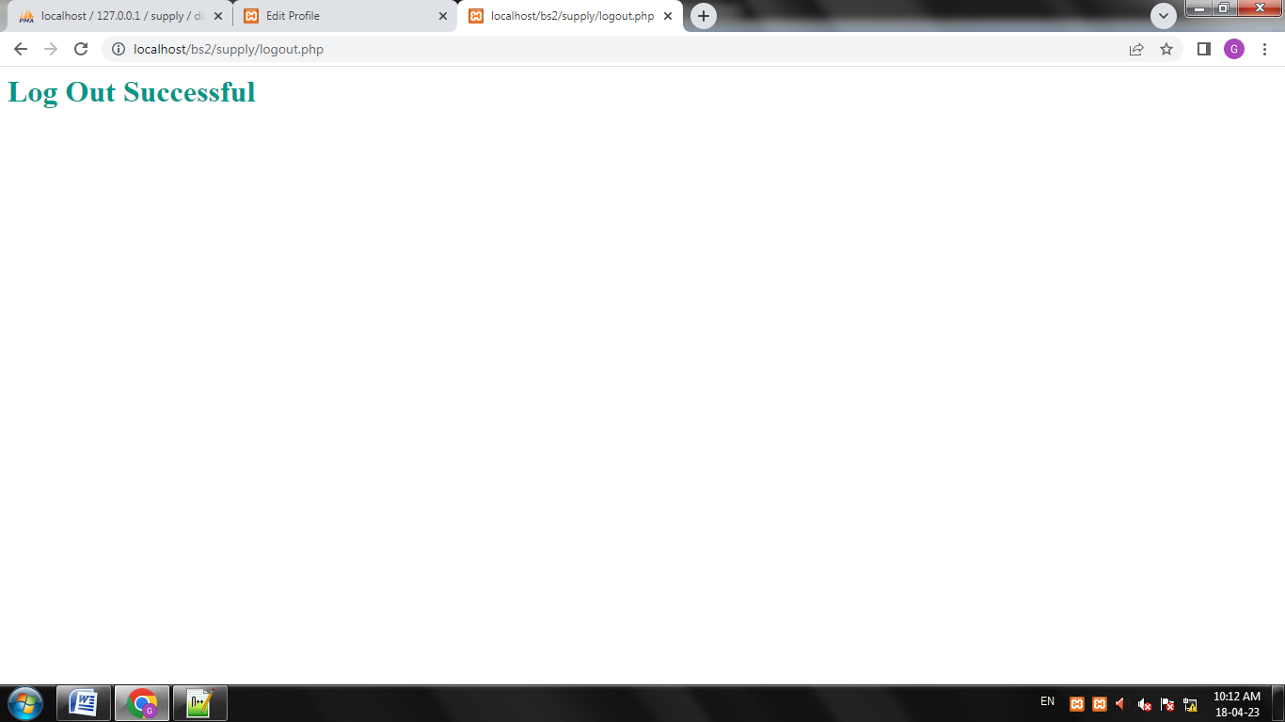

**Conclution:**

The **Supply Chain Management System** is an automated system that is developed using PHP, JavaScript, CSS, Bootstrap templates, and MySQL for the database. It contains three sections: the admin, manufacturer,Distributor and retailer. This S**upply Chain Management System** is designed as a simple and easy to use system that different users won’t find any difficulty in dealing with the system.

**Webliography:**

* **https://www.w3.org/**
* **https://www.geeksforgeeks.org/**